Submitted by,

**SRUTHI AKHIL**

svkmay31@gmail.com

**JOB PORTAL**

Software Requirements Specification

**TABLE OF CONTENTS**

1. **Introduction**
   * + 1. Purpose
       2. Scope
       3. Objectives
2. **Functional Requirements**
   * + 1. Primary actors of the system
       2. Use case diagrams
       3. User stories
       4. Business Process Diagram
3. **Non-Functional Requirements**
4. **Technical Requirements**
5. **Conclusion**

**1)INTRODUCTION**

**Purpose**

The purpose of Application is to provide jobs portal for job seekers to submit their CV and apply for job posting and Employer can select best Employees from available CV based on their payment option selection. This is basically a job portal where job seeker applies for jobs and employer post jobs and select prospective applicant. This document outlines requirements for an online job portal system. The system aims to help both job candidates and recruiters by allowing candidates to search and apply for jobs online based on their profiles and requirements, and allowing recruiters to view candidate profiles and post job listings. Key features for candidates include searching for jobs by category, company, skills, and saved searches; creating and improving profiles and resumes; and receiving job alerts and messages. Key features for recruiters include posting job listings; and viewing candidate profiles by category, skills, experience, and education. The system is intended to run on Windows with a MySQL database.

Requirements analysis is an essential process that enables the success of a system or software project to be assessed. Requirements are generally split into two types: Functional and Non-functional requirements. functional requirements define the specific behaviour or functions of a system—what the system should do to meet user needs. These include features like data processing, authentication, and user interactions. In contrast, non-functional requirements specify how the system performs its tasks, focusing on attributes like performance, security, scalability, and usability.

**What are Functional Requirements?**

These are the requirements that the end user specifically demands as basic facilities that the system should offer. All these functionalities need to be necessarily incorporated into the system as a part of the contract.

These are represented or stated in the form of input to be given to the system, the operation performed and the output expected. They are the requirements stated by the user which one can see directly in the final product, unlike the non-functional requirements.

**Examples:**

* What are the features that we need to design for this system?
* What are the edge cases we need to consider, if any, in our design?

**What are Non-Functional Requirements?**

These are the quality constraints that the system must satisfy according to the project contract. The priority or extent to which these factors are implemented varies from one project to another. They are also called non-behavioral requirements. They deal with issues like:

* Portability
* Security
* Maintainability
* Reliability
* Scalability
* Performance
* Reusability
* Flexibility

**Examples:**

* Each request should be processed with the minimum latency?
* System should be highly valuable.

**Scope**

A job portal system is like a one-stop shop for both job seekers and employers. A job portal is an application that facilitates the search for employment and ranges from large, generalized sites to specialized working groups for work categories such as engineering, law, insurance, social work, teaching, and developing mobile applications. Job Portal System will provide a very specific way to eliminate and reduce the time for the most appropriate role. The determination is to allow communication between the interested parties and complete the task of recruitment quickly. A job portal is a platform dedicated to online information about recruiters as well as job seekers. A job portal helps both job seekers and recruiters find the right organization for the employees. In the case of job seekers, according to their educational qualification, experience, and their preferences, the job portal shows the list of companies to the job seeker. And, to the recruiters, provides the suitable candidates from a pool of lacks.

User roles in the system are

* Job seeker
* Job provider
* Platform Admin

1. **Job seeker**

* Login to the portal
* Create profile
* Upload resume
* Search for a job
* Filter job listings
* Save job postings
* Apply for job
* Tracking application status

**2)Job provider**

* Signup
* Login in to the portal
* Enter company information
* Application view
* Confirmation message
* Download Resume of applicant
* Interview schedule
* Email alerts after submission of application
* Enter job details
* Automatic deletion after vacancy
* Advanced filter
* Communication
* Application process

**3)Platform Admin**

* Login to the job portal
* Portal layout development
* Content supervision
* Maintenance and Updation
* Communication management
* User management
* Job management
* Documentation

**2)OBJECTIVES**

The objective of the Job Portal System is to develop a system to enable interaction between employers and applicants.

* Improving the user experience
* Launching a new product
* Achieving financial success
* Implementing new features or strategies
* Enhancing communication channels between teams.

A job portal system aims to address the following goals or problems

* **Connect job seekers with employers**: Job portals allow job seekers to create profiles, upload resumes, and search for job openings across various industries and locations.
* **Efficient job search**: Job portals help job seekers find relevant job listings quickly.
* **Improved job listings**: Employers can optimize job listings for maximum visibility, attract relevant talent, and highlight key responsibilities and qualifications.
* **Career advancement**: Job portals offer features that aid in career progression.

**3)FUNCTIONAL REQUIREMENTS**

**Primary actors of the system**

* **Platform Admin**: Responsible for overall system administration.
* **Company/Job provider**: Represents employers seeking to hire.
* **Candidate/Job seeker**: Job seekers who use the portal to find and apply for jobs.

**A) USER CASE DIAGRAMS**

User case diagram for PLATFORM ADMIN

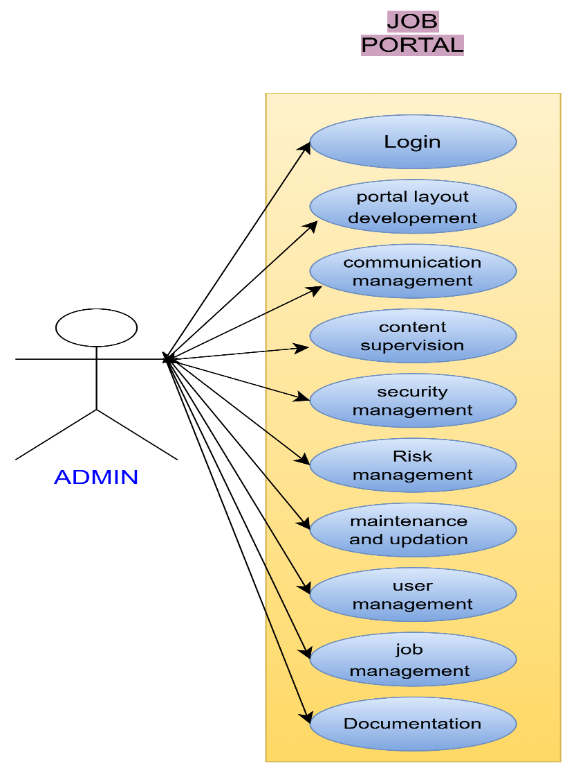

User case diagram for JOB SEEKER

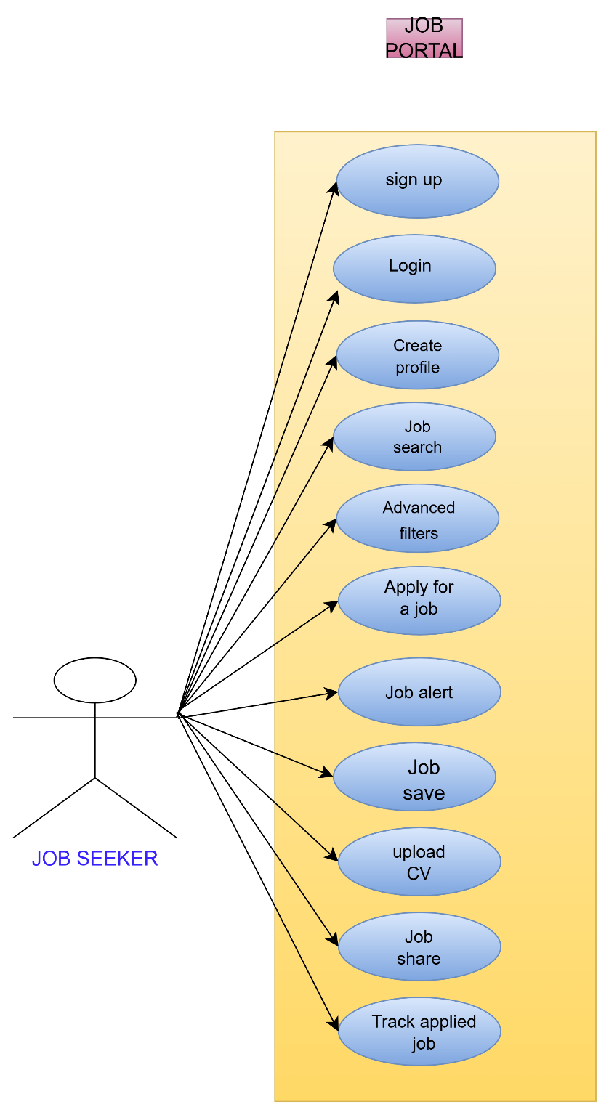

User case diagram for JOB PROVIDER

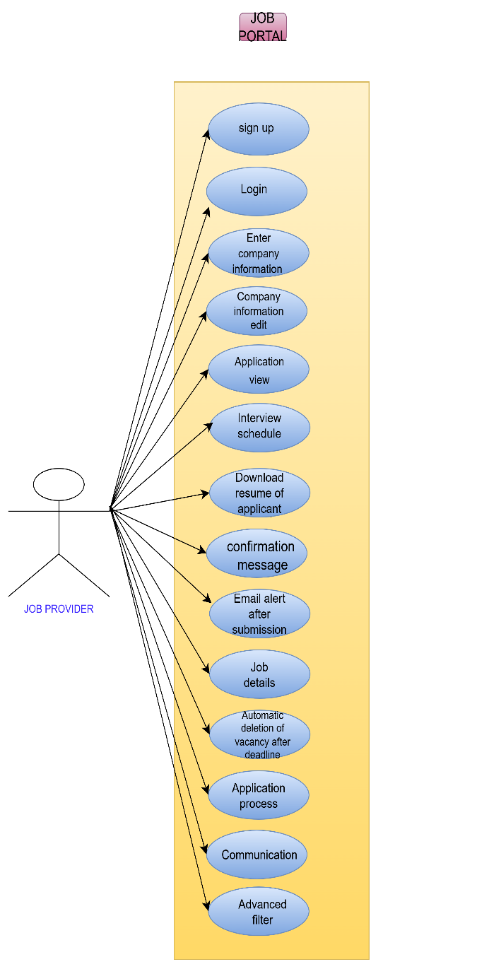

**b) USER STORIES**

User stories of JOB PROVIDER

|  |  |  |
| --- | --- | --- |
| AS A (TYPE OF USER) | I NEED TO (DO SOME TASK) | SO THAT I CAN(GET SOME RESULT) |
| Job provider | Sign up | My data available to job seekers |
| Job provider | Login into the job portal | An option for enter job portal |
| Job provider | Enter company information | Understanding company details to job seekers |
| Job provider | Company information edit | edit company details to provide correct information |
| Job provider | Application view | View candidate profile |
| Job provider | Confirmation message | Get an offer letter |
| Job provider | Interview schedule | Know the interview date,place,time |
| Job provider | Download resume of applicant | View applicant resume and filter profiles based on skills,qualification |
| Job provider | Email alerts after submission of application | It can also be helpful to get a confirmation mail to know how many candidate have applied |
| Job provider | Enter Job details | Get job details (post,location,salary) |
| Job provider | Automatic deletion of vacancy after deadline | Block profiles after expiring date |
| Job provider | Application process | An option to submit applications |
| Job provider | communication | Get a chat option |
| Job provider | Advanced filter | I will get only the required profiles |

User stories of JOB SEEKER

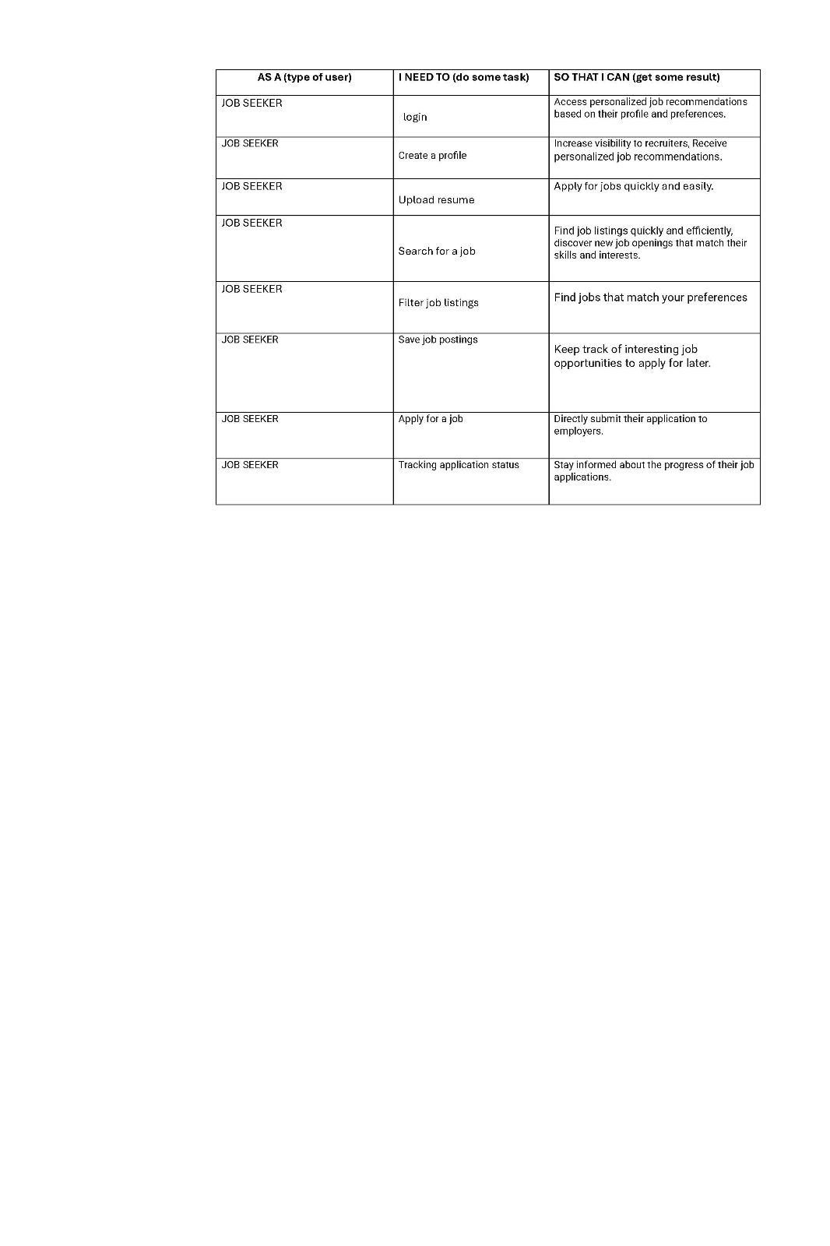

User stories of ADMIN

|  |  |  |
| --- | --- | --- |
| AS A (type of user) | NEED TO ( do some task) | SO THAT I CAN (get some result) |
| Admin | Login in to the Job portal | Access my data I have entered before |
| Admin | Portal layout development | Get a Platform |
| Admin | Content supervision | Get more contents and more information |
| Admin | Security Management | To ensure the security |
| Admin | Risk Management | Resolving the risk factors |
| Admin | Maintenance and Updation | Get smooth and updated version |
| Admin | Communication management | Collaboration with job providers and job seekers |
| Admin | User Management | Effectively manage user and their account |
| Admin | Job management | details of jobs |
| Admin | Documentation | Get all the documents of users |

C)BUSINESS PROCESS DIAGRAM

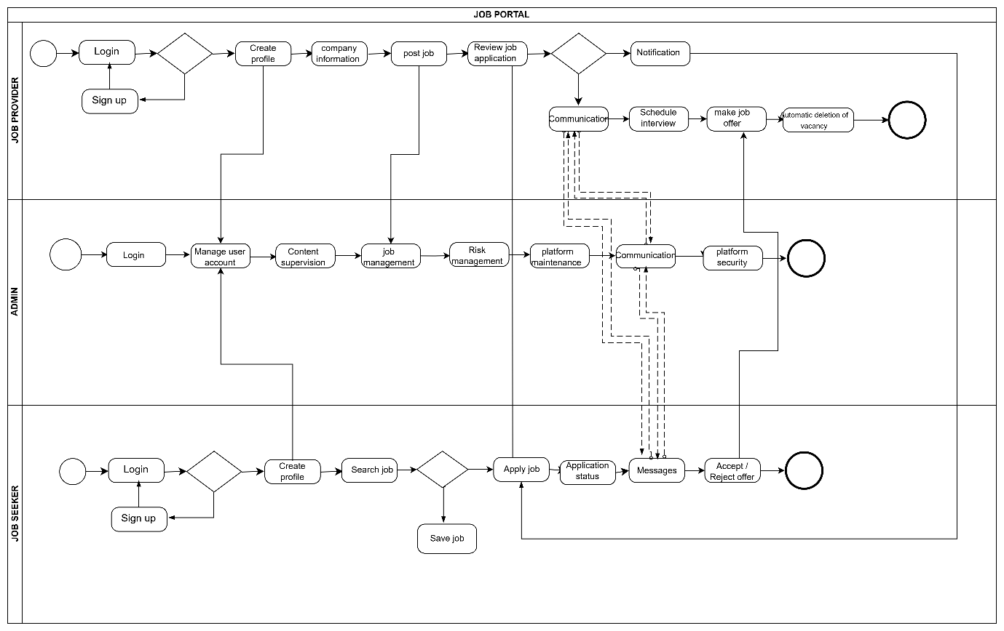

**3)NON- FUNCTIONAL REQUIREMENTS**

* **Audit Trails**: Maintain logs of user activities to detect and respond to security incidents.

**Usability**

* **User Interface**: The system should have an intuitive and user-friendly interface that is easy to navigate.

**Reliability**

* **Availability**: The system should have an uptime of 99.9%, ensuring it is available to users most of the time.
* **Fault Tolerance**: Implement mechanisms to handle and recover from failures, ensuring minimal disruption to users.

**Maintainability**

* **Modularity**: The system should be designed in a modular way to facilitate easy updates and maintenance.
* **Documentation**: Maintain comprehensive documentation for developers and administrators to streamline maintenance tasks.

**Compliance**

* **Regulatory Compliance**: Ensure the system complies with relevant regulations and standards (e.g., GDPR for data protection).

**Compatibility**

* **Browser Compatibility**: The system should be compatible with all major web browsers (e.g., Chrome, Firefox, Safari, Edge).
* **Device Compatibility**: The system should be optimized for use on various devices, including desktops, tablets, and smart-phones.

These non-functional requirements help ensure the job portal system meets performance standards, remains secure, and provides a positive user experience.

* A non-functional requirement is a requirement that specifies criteria that can be used to judge the operation of a system, rather than specific behaviour. They are contrasted with functional requirements that define specific behaviour or functions.
* The plan for implementing functional requirements are detailed in the system design.
* The plan for implementing non-functional requirements are detailed in the system architecture.
* Performance
* Reliability and recover ability
* Security
* Usability
* Interoperable
* Data Migration

following categories are the main areas of attention for non-functional requirements.

**Performance**

* **Response Time**: The system should respond to user actions (e.g., searching for jobs, submitting applications) within 2 seconds.
* **Throughput**: The system should be able to handle a large number of concurrent users, with a target of supporting 10,000 active users simultaneously without performance degradation.

**Scalability**

* **Vertical Scalability**: The system should support scaling up by adding more resources to existing servers.
* **Horizontal Scalability**: The system should support scaling out by adding more servers to handle increased load.

**Security**

* **Data Protection**: Implement strong encryption for data at rest and in transit to protect sensitive information.
* **Authentication and Authorization**: Ensure secure user authentication and role-based access control to restrict access to sensitive data and functionalities.

**4)TECHNICAL REQUIREMENTS**

**Hardware**

The system requires following hardwares

* RAM: 1 GB (further increase that as per requirement.)
* Hard disk: 80GB (further increase that as per requirement.)
* Display: 1024*768 , True Type Colour-32 Bit
* Mouse: Any normal Mouse.
* Keyboard: Any window supported Keyboard.

**Software**

* Database Server: Microsoft SQL Server
* Web Server: Internet Information Server
* Technologies: HTML, CSS, ASP.NET, JavaScript
* ASP.NET core backend
* ANGULAR Frontend

**5)CONCLUSIONS**

challenging project. This project proved good for me as it provided practical knowledge of not only programming in ASP.NET web based application and no some extent Windows application and SQL server, but also about all handling procedure related with job portal. It has been a great pleasure for me to work on this exciting and

